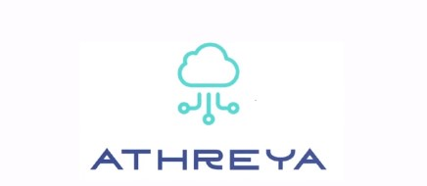

PROJECT ON
INTRUSION DETECTION SYSTEM (USING HONEYPOT)

CONTENTS :
- SDLC (Software development life cycle)
- Planning
- Analysis
- Design
- Modules of SDLC
- Waterfall Module
- Iterative Model
- Spiral Model
- V-Model
- Big Bang MODEL
- SDLC For IDS Using Honeypot
- Planning
- Identify the summary of the project
- Identify the objectives and goals of the software project
- Determine the scope and Boundaries of the project
- Identify the tool and technologies we need for the project
- Analysis
Project Overview
- Introduction
- Project Scope
- Software Requirements
- Languages used
- Design
- Architecture Design.
- Flow Diagram
- Design the database schema
- USE CASE

- Purpose of Use case Diagram
- Building blocks
- Structural Things
- Behavioral Things
- Grouping Things
- Relationships

- Use case for IDS using Honeypot
- Use case for Actor 1
- Use case for Actor 2
- Use case for Actor 3

- Advantages of IDS using Honeypot

- Conclusion

1)SDLC (Software development life cycle)
The software development lifecycle (SDLC) is the cost-effective and time-efficient process that development teams use to design and build high-quality software. The goal of SDLC is to minimize project risks through forward planning so that software meets customer expectations during production and beyond. This methodology outlines a series of steps that divide the software development process into tasks you can assign, complete, and measure.

Importance of SDLC
Software development can be challenging to manage due to changing requirements, technology upgrades, and cross-functional collaboration. The software development lifecycle (SDLC) methodology provides a systematic management framework with specific deliverables at every stage of the software development process. As a result, all stakeholders agree on software development goals and requirements upfront and also have a plan to achieve those goals.
Here are some benefits of SDLC:
- Increased visibility of the development process for all stakeholders involved
- Efficient estimation, planning, and scheduling
- Improved risk management and cost estimation
- Systematic software delivery and better customer satisfaction
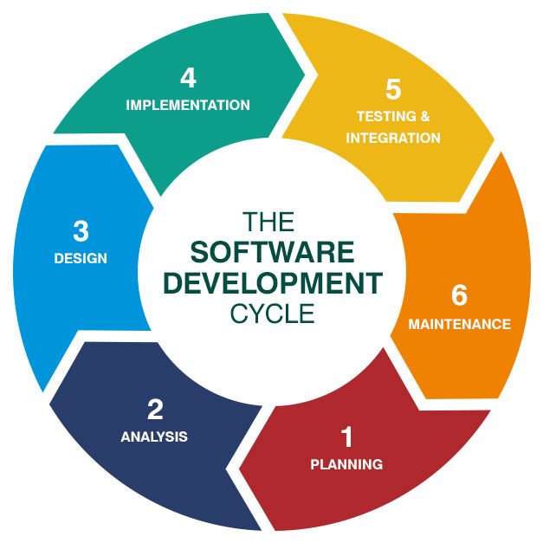
Software Development Life Cycle Stages
Stage 1 — Planning & Requirements Analysis
At the start of software development life cycle stages, the need to attract the most talented and experienced engineers inevitably arises. By considering the demands of the client, a skillful crew can create a reliable foundation for the rest of the software development life cycle phases.
This stage has a number important steps. First, the team working on the project conducts a preliminary analysis to discover the aims and issues of their client. Based on the results, they propose a set of possible solutions, with a budget for each.
Stage 2 — Defining Requirements
The sequence of software development life cycle stages continues with a deep dive into the requirements, after the client has chosen a software solution. The team analyses documents related to the project, evaluates the client’s existing ecosystem. This is one the software development life cycle steps that some consider transitional, performing it alongside planning and requirements analysis.
Stage 3 — Designing Product Architecture
Having fully analyzed the client’s requirements on previous software development life cycle stages, the developers create several product architectures and show them to the client.
The chosen architecture is then finalised in a Design Document Specification (DDS) and evaluated by all sides in terms of risks, operational reliability, universality, and cost-effectiveness. This architecture becomes the foundation for all next stages of software development life cycle and the software product in question.
Stage 4 — Developing the Product
One of the most critical software development life cycle phases, this one aims at producing working code and showing results to the client. The development takes the majority of time in any project. Often, the project exceeds the initially estimated time: the client might consider adding something to the project scope in the course of the development process
Stage 5 — Testing the Product
After all the preparations on previous stages of software development life cycle are completed, quality assurance engineers start scouting for bugs. Testing is another crucial step among the SDLC life cycle phases as it allows for fixing critical problems before they will lead to critical loses.
Stage 6 — Deployment & Maintenance
To guarantee the proper work of the finished digital solution in the future, after all the SDLC life cycle phases are completed, the client can order general product maintenance to fix different issues (which inevitably emerge with any modern software product). This step completes the software development life cycle.
2)MODULES OF SDLC
- Waterfall model
- The Waterfall Model was the first Process Model to be introduced. It is also referred to as a linear-sequential life cycle model. It is very simple to understand and use. In a waterfall model, each phase must be completed before the next phase can begin and there is no overlapping in the phases.
- The Waterfall model is the earliest SDLC approach that was used for software development.
- The waterfall Model illustrates the software development process in a linear sequential flow. This means that any phase in the development process begins only if the previous phase is complete. In this waterfall model, the phases do not overlap.
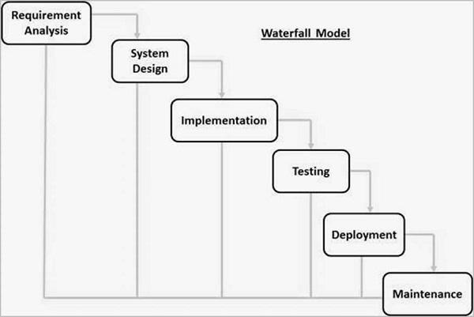

Advantages
- Simple and easy to understand and use
- Easy to manage due to the rigidity of the model. Each phase has specific deliverables and a review process.
- Phases are processed and completed one at a time.
- Works well for smaller projects where requirements are very well understood.

Disadvantages
- No working software is produced until late during the life cycle.
- High amounts of risk and uncertainty.
- Not a good model for complex and object-oriented projects.
- Poor model for long and ongoing projects.

The Waterfall Model was the first Process Model to be introduced. It is also referred to as a linear-sequential life cycle model. It is very simple to understand and use. In a waterfall model, each phase must be completed before the next phase can begin and there is no overlapping in the phases.
- Iterative model
- In the Iterative model, iterative process starts with a simple implementation of a small set of the software requirements and iteratively enhances the evolving versions until the complete system is implemented and ready to be deployed.
- An iterative life cycle model does not attempt to start with a full specification of requirements. Instead, development begins by specifying and implementing just part of the software, which is then reviewed to identify further requirements. This process is then repeated, producing a new version of the software at the end of each iteration of the model.
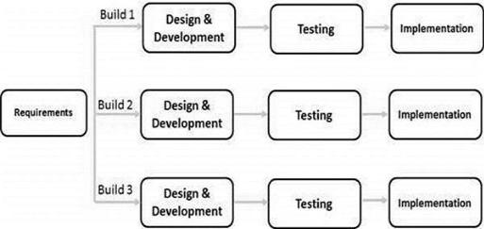

Advantages
- Results are obtained early and periodically.
- Parallel development can be planned.
- Progress can be measured.
- Less costly to change the scope/requirements.
- Testing and debugging during smaller iteration is easy.
- Risks are identified and resolved during iteration; and each iteration is an easily managed milestone.
Disadvantages
- More resources may be required.
- Although cost of change is lesser, but it is not very suitable for changing requirements.
- More management attention is required.
- System architecture or design issues may arise because not all requirements are gathered in the beginning of the entire life cycle.
- Defining increments may require definition of the complete system.

- Spiral Model
Spiral model is one of the most important Software Development Life Cycle models, which provides support for Risk Handling. In its diagrammatic representation, it looks like a spiral with many loops. The exact number of loops of the spiral is unknown and can vary from project to project. Each loop of the spiral is called a Phase of the software development process. The exact number of phases needed to develop the product can be varied by the project manager depending upon the project risks. As the project manager dynamically determines the number of phases, so the project
The below diagram shows the different phases of the Spiral Model: –

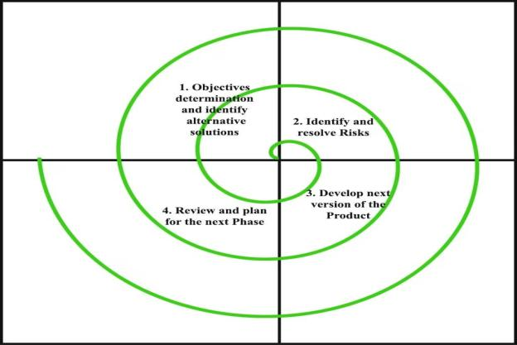

Advantages
- Risk Handling: The projects with many unknown risks that occur as the development proceeds, in that case, Spiral Model is the best development model to follow due to the risk analysis and risk handling at every phase.
- Good for large projects: It is recommended to use the Spiral Model in large and complex projects.
- Flexibility in Requirements: Change requests in the Requirements at later phase can be incorporated accurately by using this model.
Disadvantages
- Complex: The Spiral Model is much more complex than other SDLC models.
- Expensive: Spiral Model is not suitable for small projects as it is expensive.
- Too much dependability on Risk Analysis: The successful completion of the project is very much dependent on Risk Analysis. Without very highly experienced experts, it is going to be a failure to develop a project using this model.
- Difficulty in time management: As the number of phases is unknown at the start of the project, so time estimation is very difficult.
- SDLC V-Model
The V-model is a type of SDLC model where process executes in a sequential manner in V-shape. It is also known as Verification and Validation model. It is based on the association of a testing phase for each corresponding development stage. Development of each step directly associated with the testing phase. The next phase starts only after completion of the previous phase i.e. for each development activity, there is a testing activity corresponding to it.
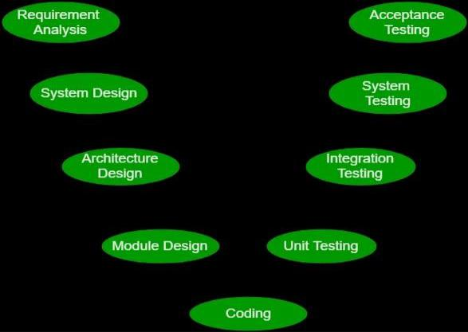
Advantages:
- This is a highly disciplined model and Phases are completed one at a time.
- V-Model is used for small projects where project requirements are clear.
- Simple and easy to understand and use.
- This model focuses on verification and validation activities early in the life cycle thereby enhancing the probability of building an error-free and good quality product.
Disadvantages:
- High risk and uncertainty.
- It is not a good for complex and object-oriented projects.
- It is not suitable for projects where requirements are not clear and contains high risk of changing.
- This model does not support iteration of phase.

- Big Bang Model
The Big Bang model is an SDLC model where we do not follow any specific process. The development just starts with the required money and efforts as the input, and the output is the software developed which may or may not be as per customer requirement. This Big Bang Model does not follow a process/procedure and there is a very little planning required. Even the customer is not sure about what exactly he wants and the requirements are implemented on the fly without much analysis.
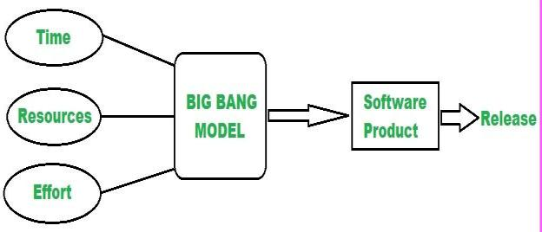

Advantages
- This is a very simple model
- Little or no planning required
- Easy to manage

Disadvantages
- Very High risk and uncertainty.
- Not a good model for complex and object-oriented projects.
- Poor model for long and ongoing projects.
- Can turn out to be very expensive if requirements are misunderstood.

3)SDLC For IDS Using Honeypot
- Planning
In the planning phase, IT Project Manager plans the schedule and budget of the project. All the plans are documented in Project Plan document.
Web security is important to keeping hackers and cyber-thieves from accessing sensitive information. Without a proactive security strategy, businesses risk the spread and escalation of malware, attacks on other websites, networks, and other IT infrastructures. If a hacker is successful, attacks can spread from computer to computer, making it difficult to find the origin.
Summary of the project
- Our project is “IDS using Honeypot”. Here we are protecting a website from Hackers through a Honeypot.
- Hacker tries to exploit actions of real user by uploading a malicious file to a website.
- Once a hacker gets username and password, he will try to upload a file which contains size of above 500MB where we have to upload less than or equal to 500 MB.
- Only real user will be having capacity to compress a file and make a 500MB file.
- So, hacker will try to upload malicious file of above 500MB repeatedly, In the mean time IDS detects him as Hacker and adds him in block list.
- Incase a real user get blocked then he can use his personal information which is asked by website to unblock themselves as Hacker can’t provide a real user’s personal information.
- Thus, we have used IDS using Honeypot to protect our website from Hacker.
Identity objective or goals of the software projects
- Objectives of Project
- The main objective of Project is to prevent Hacker actions on a website
- Honeypot helps to improve quality and security of a website
- We can protect website in less cost as WordPress websites seem to be the top target of cybercriminals and hackers. It is due to its huge user base that accounts for almost 40% of all websites worldwide.

- Goals of the Project
- The primary goal of the project is to protect a website from unauthorized persons
- To refine a website intrusion detection system (IDS) and threat response so it is in a better position to manage and prevent attack
- To reduce the number of false positives because there is no reason for legitimate users to access the honeypot.
- To increase and maintain privacy for sensitive data of a user
- To detect suspicious activities and generate alerts when they are detected.


Scope and Boundaries of the Project
- Honeypot systems often use hardened operating systems (OSes) where extra security measures have been taken to minimize their exposure to threats.
- Honeypot are usually configured so they appear to offer attackers exploitable vulnerabilities.
- capture information from unauthorized intruders that are tricked into accessing them because they appear to be a legitimate part of the network.
- One team will be handling frontend of the software and another will be handling backend.
- Third team is assigned to maintain database of a website
- Frontend team will always maintain appearance of website.
- Backend teams maintains blocklist of Hacker and other section of website.
- Teams will have discussions and meets in every stage of SDLC
- Security will be verified through various tests like penetration testing
- The website will automatically update all the data
Identify the tools and technologies we need for the Project
Using web development tools is crucial when working as a web developer, as they help you create, edit, maintain, and troubleshoot applications.
we considered the following aspects to use following tools:
- Complexity. Before investing in a web development tool, ensure it meets your actual needs and capabilities.
- Security. A good web development tool should provide web application security solutions like cross-site scripting (XSS) management, Web Application Firewalls (WAF), and security audits to protect your app from cyber attacks.
- Scalability. The tool should work with small and large projects.
- Cost. Consider its pricing system, as some web developer tools are free, while others have a monthly or yearly subscription system.
- Programming languages. Pick web development tools that are compatible with the programming language you use.
- Platform support. Check if the web development tool will provide adequate assistance and support in case of software issues.
we used the following web development tools each of which serves a unique purpose:
- Code editors. They come with built-in features that make writing and editing code easier, such as syntax highlighting, code auto-completion, and a debugger.
- Browser developer tools. They allow developers to preview HTML and CSS changes as well as write and debug JavaScript code directly on a browser.
- Web prototype software. The web development tool should include everything you need to create interactive prototypes, wireframes, and UX/UI design projects.
- Package managers. They make it easy to download and install framework and library dependencies.
- JavaScript libraries. A collection of pre-written code snippets for carrying out common JavaScript tasks.
- Container management software. The application’s source code is bundled together with its libraries and dependencies. As a result, it can run quickly and reliably on any platform.
- CSS preprocessors. They automate repetitive tasks, such as reducing code errors, producing reusable code snippets, and maintaining code compatibility.
- Web servers. Stores and transfers website data in response to a request.
Chrome Developer Tools
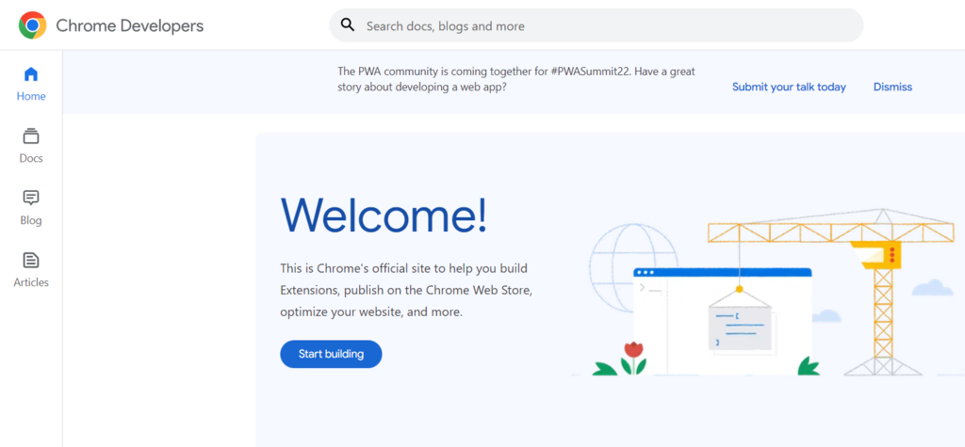
Chrome Developer Tools are a set of web editing and debugging tools built into the Google Chrome browser.
Key Features.
- Web design features. Web designers can check various web page designs and layout changes with its Inspect Element tool. Use its interactive Color Picker to grab colors from any website element and switch between color modes.
- Console utility. This feature is used for debugging JavaScript code. Users can also create live expressions and pin them at the top of the console to monitor their values in real time.
- Profiling tools. View memory usage of a web page with Chrome Task Manager. It is often used to identify memory leaks or bloat that can slow down a site’s performance.
- Built-in security features. They verify the authenticity of a web page by enabling users to view a site’s SSL certificate and TLS status.
- Device mode. Test your website design’s responsiveness, modify device performance, and limit network speed.
Eclipse ide
Visual Studio Code is an open-source code editor that runs on Windows, Linux, and macOS. It includes built-in features such as syntax highlighting, auto-complete, and Git commands to make coding faster and easier.
Features of Eclipse IDE
- For any software the software update system is always the key mechanism. For the eclipse IDE the software update system is very simple as the developer can easily add the plug-ins that help the developer to develop the advanced version of applications.
- The dependencies are very limited in the eclipse platform as the IDE gives the facility by providing simple dialog box in which user select the software and add-ons that needed to be in eclipse platform.
- Enterprise based java tooling is supported by the eclipse platform. As there are several tools available in this IDE for creating the JEE projects. The user can download the JavaEE bundle that can be used for developing the web-based applications.
- The platform also supports JPA tooling and JSF tooling, web service development and also supports to edit the XML files. In the platform the server view tab is available in which application can be deployed in any server as per user requirements.

II. Analysis
Introduction
- A Honeypot is a software-based security device, deployed to attract hackers by displaying services and open ports which are potentially vulnerable. While the attackers are diverted, their activities can then be monitored and analyzed to identify current attack methods and trend
- Network monitoring can be carried out data collection, analysis and visualization techniques.
- Dionaea, a low-interaction honeypot, is used to collect and analyze attack-data to understand the trends of cyber-attacks and to create a profile of the attacker from the analyzed data. Security tools such as honeypots, sandbox and virtual machines are called emulated monitoring system.



Project Scope
- Honeypot are usually configured so they appear to offer attackers exploitable vulnerabilities.
- capture information from unauthorized intruders that are tricked into accessing them because they appear to be a legitimate part of the network.
- One team will be handling frontend of the software and another will be handling backend.
- Third team is assigned to maintain database of a website
- Frontend team will always maintain appearance of website.
Software Requirements
Any project will be having a software to code, similarly in our project we are using VS code studio that is visual studio to design our website
- Visual Studio Code combines the simplicity of a source code editor with powerful developer tooling, like IntelliSense code completion and debugging.
- First and foremost, it is an editor that gets out of your way. The delightfully frictionless edit-build-debug cycle means less time fiddling with your environment, and more time executing on your ideas.
- Available for macOS, Linux, and Windows
- VS Code also integrates with build and scripting tools to perform common tasks making everyday workflows faster. VS Code has support for Git so you can work with source control without leaving the editor including viewing pending changes diffs
- Visual Studio Code includes a public extensibility model that lets developers build and use extensions, and richly customize their edit-build-debug experience.
Language used for this the Project
In this project we create a website so we are using website creating languages like and Java, MySQL
For backend we require object-oriented program that is Java

Java
Java is a widely used object-oriented programming language and software platform that runs on billions of devices, including notebook computers, mobile devices, gaming consoles, medical devices and many others. The rules and syntax of Java are based on the C and C++ languages.

One major advantage of developing software with Java is its portability. Once you have written code for a Java program on a notebook computer, it is very easy to move the code to a mobile device. When the language was invented in 1991 by James Gosling of Sun Microsystems (later acquired by Oracle), the primary goal was to be able to "write once, run anywhere."
It's also important to understand that Java is much different from JavaScript. Javascript does not need to be compiled, while Java code does need to be compiled. Also, Javascript only runs on web browsers while Java can be run anywhere.

New and improved software development tools are coming to market at a remarkable pace, displacing incumbent products once thought to be indispensable. In light of this continual turnover, Java’s longevity is impressive; more than two decades after its creation, Java is still the most popular language for application software development—developers continue to choose it over languages such as Python, Ruby, PHP, Swift, C++, and others. As a result, Java remains an important requirement for competing in the job market.
MySQL
MySQL is the world’s most popular open source database. According to DB-Engines, MySQL ranks as the second-most-popular database, behind Oracle Database. MySQL powers many of the most accessed applications, including Facebook, Twitter, Netflix, Uber, Airbnb, Shopify, and Booking.com.

Since MySQL is open source, it includes numerous features developed in close cooperation with users over more than 25 years. So it’s very likely that your favorite application or programming language is supported by MySQL Database.

Databases are the essential data repository for all software applications. For example, whenever someone conducts a web search, logs in to an account, or completes a transaction, a database system is storing the information so it can be accessed in the future.

A relational database stores data in separate tables rather than putting all the data in one big storeroom. The database structure is organized into physical files optimized for speed. The logical data model, with objects such as data tables, views, rows, and columns, offers a flexible programming environment. You set up rules governing the relationships between different data fields, such as one to one, one to many, unique, required, or optional, and “pointers” between different tables. The database enforces these rules so that with a well-designed database your application never sees data that’s inconsistent, duplicated, orphaned, out of date, or missing.

The “SQL” part of “MySQL” stands for “Structured Query Language.” SQL is the most common standardized language used to access databases. Depending on your programming environment, you might enter SQL directly (for example, to generate reports), embed SQL statements into code written in another language, or use a language-specific API that hides the SQL syntax.

III.DESIGN
- Architecture Diagram
- Architecture diagramming is the process of creating visual representations of software system components. In a software system, the term architecture refers to various functions, their implementations, and their interactions with each other.
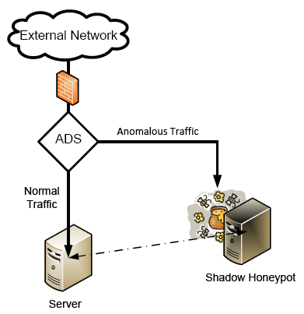
- Based on the efficient architecture, a software-defined networking-enabled honeypot system is designed, which supplies a high programmability for technically sustaining the features for capturing high-quality data. A proof-of-concept system is implemented to validate its feasibility and effectiveness . A honeypot is a security mechanism that creates a virtual trap to lure attackers.

- Flow Diagram
A flow diagram is a visualization of a sequence of actions, movements within a system and/or decision points. They’re a detailed explanation of each step in a process, no matter the level of complexity of that process.
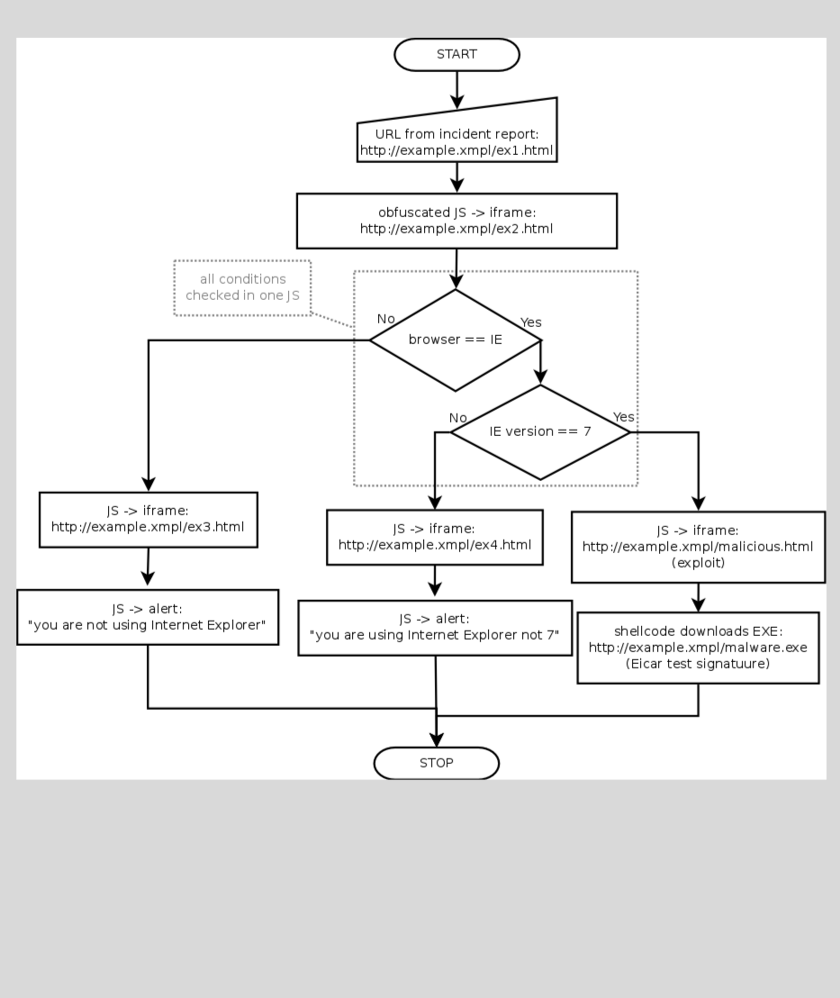
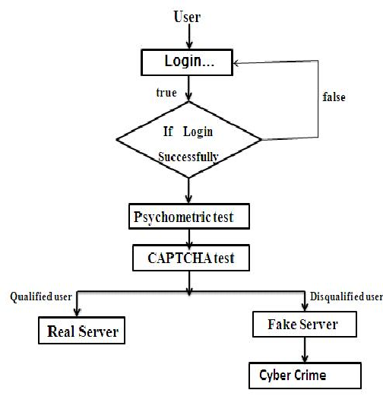
- Design the database schema
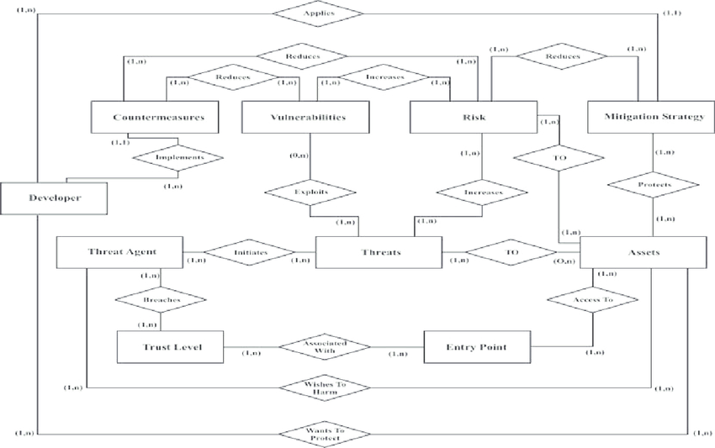

- A database schema defines how data is organized within a relational database; this is inclusive of logical constraints such as, table names, fields, data types, and the relationships between these entities.
- The database schema is a term used for a structure or layout defining a set of data. In other words, it describes how the data will be organized and connected. Hence, a database schema may include schema objects like tables, views, fields, relationships, packages, indexes, types, and many other elements.

4)USE CASE
Use-case diagrams describe the high-level functions and scope of a system. These diagrams also identify the interactions between the system and its actors. The use cases and actors in use-case diagrams describe what the system does and how the actors use it, but not how the system operates internally.
- Purpose of Use case Diagram
- Specify the context of a system.
- Capture the requirements of a system.
- Validate a systems architecture.
- Drive implementation and generate test cases.
Guidelines to create Use case :
- The name of a use case is very important. The name should be chosen in such a way so that it can identify the functionalities performed.
- Give a suitable name for actors.
- Show relationships and dependencies clearly in the diagram.
- Do not try to include all types of relationships, as the main purpose of the diagram is to identify the requirements.
- Use notes whenever required to clarify some important points.
Following is a sample use case diagram representing the order management system. Hence, if we look into the diagram then we will find three use cases (Order, SpecialOrder, and NormalOrder) and one actor which is the customer.
The SpecialOrder and NormalOrder use cases are extended from Order use case. Hence, they have extended relationship. Another important point is to identify the system boundary, which is shown in the picture. The actor Customer lies outside the system as it is an external user of the system.
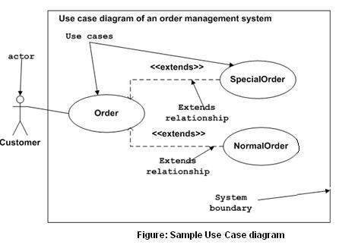

- Building blocks
UML is composed of three main building blocks, i.e., things, relationships, and diagrams. Building blocks generate one complete UML model diagram by rotating around several different blocks. It plays an essential role in developing UML diagrams. The basic UML building blocks are enlisted below:
- Things
- Relationships
- Diagrams

Things
Anything that is a real world entity or object is termed as things. It can be divided into several different categories:
- Structural things
- Behavioral things
- Grouping things
- Annotational things

Structural things
Nouns that depicts the static behavior of a model is termed as structural things. They display the physical and conceptual components. They include class, object, interface, node, collaboration, component, and a use case.
Use case: Use case is the core concept of object-oriented modeling. It portrays a set of actions executed by a system to achieve the goal.
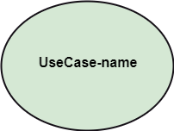
Actor: It comes under the use case diagrams. It is an object that interacts with the system, for example, a user.
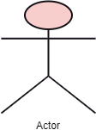

Behavioral Things
They are the verbs that encompass the dynamic parts of a model. It depicts the behavior of a system. They involve state machine, activity diagram, interaction diagram, grouping things, annotation things
State Machine: It defines a sequence of states that an entity goes through in the software development lifecycle. It keeps a record of several distinct states of a system component.
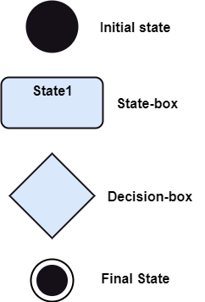

3.Grouping Things
It is a method that together binds the elements of the UML model. In UML, the package is the only thing, which is used for grouping.
Package: Package is the only thing that is available for grouping behavioral and structural things.
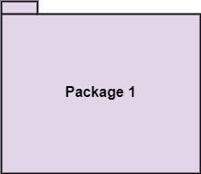

4.Annotation Things
It is a mechanism that captures the remarks, descriptions, and comments of UML model elements. In UML, a note is the only Annotational thing.
Note: It is used to attach the constraints, comments, and rules to the elements of the model. It is a kind of yellow sticky note.
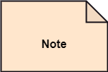

Relationships
It illustrates the meaningful connections between things. It shows the association between the entities and defines the functionality of an application. There are four types of relationships given below:
1.Dependency: Dependency is a kind of relationship in which a change in target element affects the source element, or simply we can say the source element is dependent on the target element. It is one of the most important notations in UML. It depicts the dependency from one entity to another.
It is denoted by a dotted line followed by an arrow at one side as shown below,
2.Association: A set of links that associates the entities to the UML model. It tells how many elements are actually taking part in forming that relationship.
It is denoted by a dotted line with arrowheads on both sides to describe the relationship with the element on both sides.
3.Generalization: It portrays the relationship between a general thing (a parent class or superclass) and a specific kind of that thing (a child class or subclass). It is used to describe the concept of inheritance.
It is denoted by a straight line followed by an empty arrowhead at one side.

4.Realization: It is a semantic kind of relationship between two things, where one defines the behavior to be carried out, and the other one implements the mentioned behavior. It exists in interfaces.
It is denoted by a dotted line with an empty arrowhead at one side.


5)Use case for IDS using Honeypot
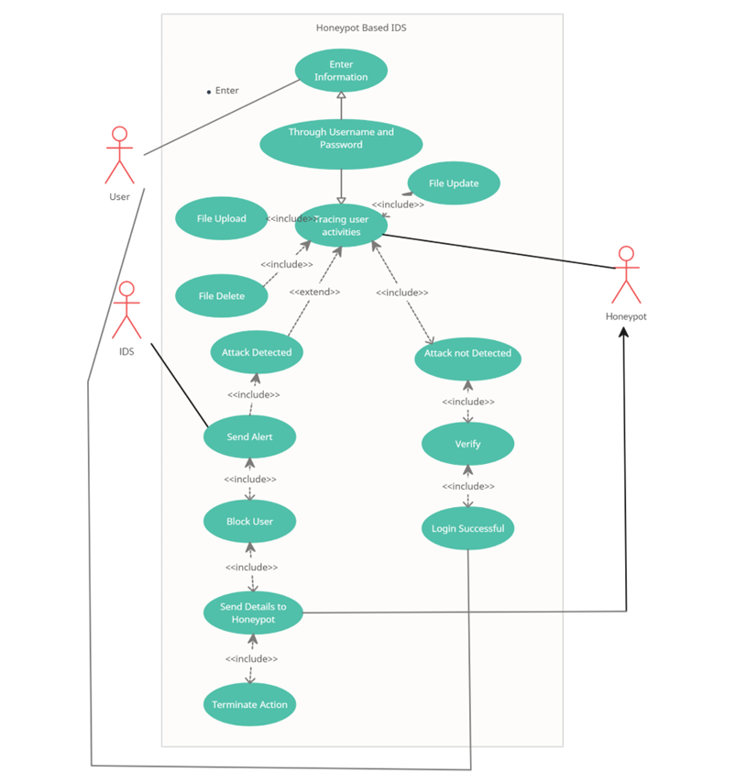

- Use case for Actor 1
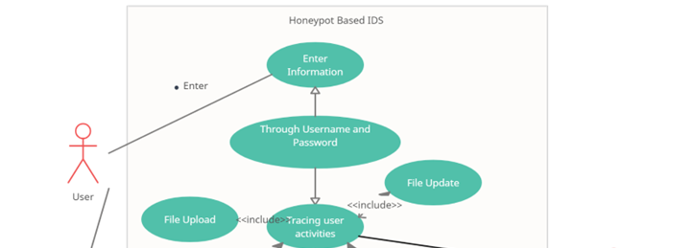

- Use case for Actor 2
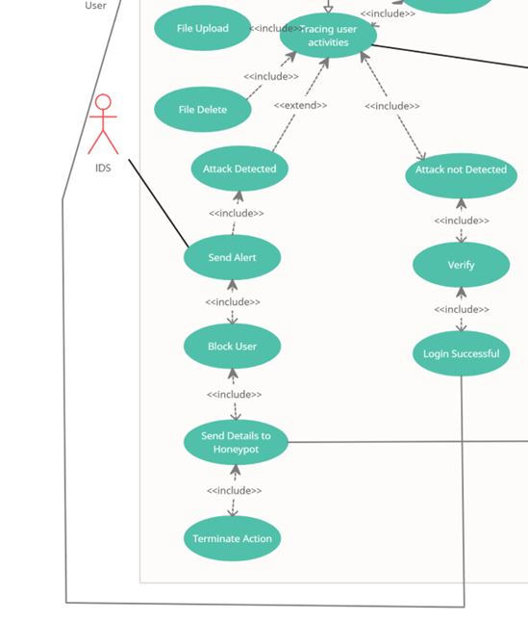

- Use case for Actor 3
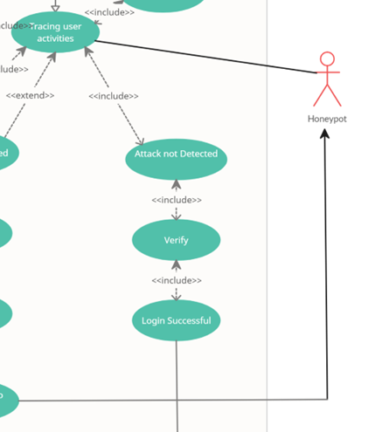
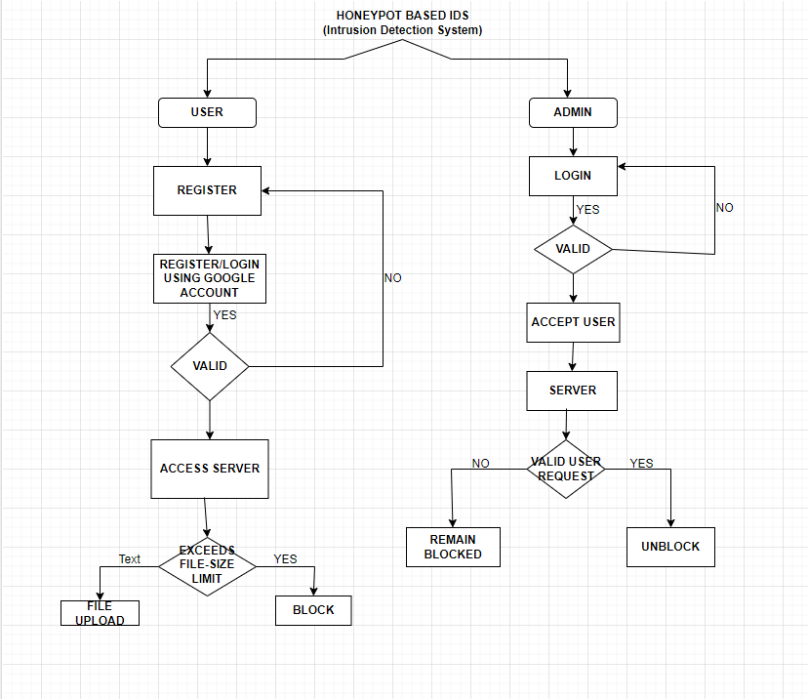
ACTIVITY DIAGRAM

6)Advantages of IDS using Honeypot
- Honeypots can be a good way to expose vulnerabilities in major systems.
- The big advantage of using honeypot security is that these malicious addresses might be the only ones you see, making the attack much easier to identify. Because honeypots handle very limited traffic, they are also resource light.
- The purpose of a honeypot is to refine an organization's intrusion detection system (IDS) and threat response so it is in a better position to manage and prevent attacks.
- They break the attacker kill chain and slow attackers down.
- They are straightforward and low-maintenance.
- They help you test your incident response processes.
- Honey pots provide an environment where intruders can be trapped or vulnerabilities accessed before an attack is made on real assets.
- First, honeypots make it possible for an administrator to learn methods that are used by hackers.

Requirements for a honeypot
A honeypot can be deployed on any PC, but it is typically set up on a separate dedicated machine or virtual machine that is not used for any other purpose. This is done to isolate the honeypot from the rest of the network and to prevent attackers from using it as a gateway to access other systems.

The hardware requirements for a honeypot depend on the number of systems being emulated and the level of activity expected on the honeypot. For a small honeypot with a few emulated systems and low activity, a basic PC with moderate processing power and memory should suffice. However, for a larger honeypot with multiple emulated systems and high levels of activity, a more powerful machine may be required.

The software requirements for a honeypot depend on the type of honeypot being deployed and the systems being emulated. For example, if the honeypot is emulating Windows systems, the honeypot machine should be running a version of Windows, while if the honeypot is emulating Linux systems, the machine should be running a Linux distribution.

Overall, the hardware and software requirements for a honeypot will depend on the specific deployment scenario and the goals of the honeypot. It is important to carefully consider these requirements and ensure that the honeypot is configured and deployed in a secure and effective manner.

7)Conclusion
- Honeypots, like all technologies have their drawbacks, the biggest being their limited field of view. Honeypots only capture activity directed against them and will miss attacks on other systems. For that reason, security experts do not recommend replacing existing security technologies with those systems.
- Production honeypots—serve as decoy systems inside fully operating networks and servers, often as part of an intrusion detection system (IDS). They deflect criminal attention from the real system while analyzing malicious activity to help mitigate vulnerabilities.

THANK YOU

